A typical HTML page looks like this:

<html>

<head>

<title>Page title</title>

</head>

<body>

<h1>This is a heading</h1>

<p>This is a paragraph.</p>

<p>This is another paragraph.</p>

</body>

</html>

Almost every website uses this structure. The main content goes inside the body tag. No worries if this looks complicated; let's break it down!

**Note:** These are the essential elements for a basic HTML document: **<!DOCTYPE html>, <html>, <head>, <title>, </head>, <body>, </body>, </html>**

**POINTS:**

* The <!DOCTYPE html> tag specifies that the document is an HTML5 document.
* The <html lang="en"> tag defines the document to be in English.
* The <head> section contains metadata and the title of the webpage, which appears in the browser's title bar.
* The <body> section contains the content that will be displayed on the webpage.
* The h1 and p are two types of tags. We will learn about more tags in the later section

**Visualization of an HTML Document:**The following image provides a visual representation of the HTML structure:

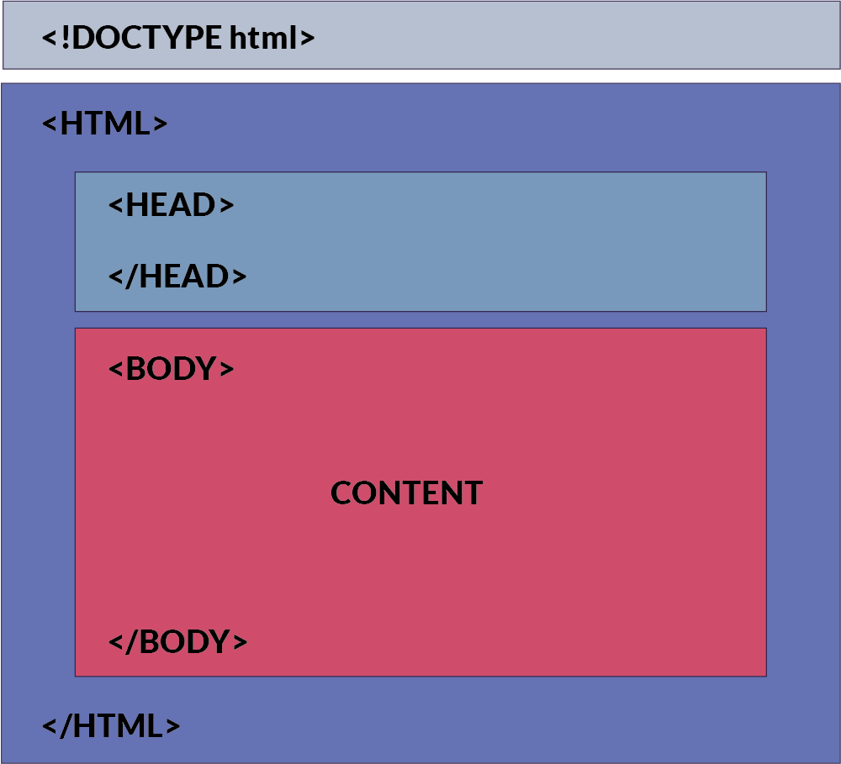

**HTML Tags**

If you want to build a beautiful website, tags are essential elements that help you achieve that.

An HTML tag acts as a container for content or other HTML tags. Tags are words enclosed within < and > angle brackets.

They serve as keywords that instruct the web browser on how to format and display the content.

**Document Structure Tags**

* <!DOCTYPE html>: Specifies the document type.
* <html>: Encloses the entire HTML document.
* <head>: Contains meta-information and links to scripts and stylesheets.
* <body>: Contains the content of the web page.

### **Metadata Tags**

* <title>: Sets the title of the web page.
* <meta>: Provides metadata such as character set, author, and viewport settings.
* <link>: Links external resources like stylesheets.

### **Text Formatting Tags**

* <p>: Paragraph.
* <h1>, <h2>, <h3>, <h4>, <h5>, <h6>: Headings.
* <strong>: Strong emphasis (typically bold).
* <em>: Emphasis (typically italic).
* <br>: Line break.
* <hr>: Horizontal rule.

**List Tags**

* <ul>: Unordered list.
* <ol>: Ordered list.
* <li>: List item.

**Hyperlink and Media Tags**

* <a>: Anchor (used for links).
* <img>: Image.
* <audio>: Audio content.
* <video>: Video content.

**Form Tags**

* <form>: Form.
* <input>: Input field.
* <textarea>: Text area.
* <button>: Button.
* <select>: Dropdown list.
* <option>: Options within a <select> or <datalist>.

**Table Tags**

* <table>: Table.
* <tr>: Table row.
* <td>: Table data cell.
* <th>: Table header cell.
* <thead>: Table header group.
* <tbody>: Table body group.
* <tfoot>: Table footer group.

**Semantic Tags**

1. <header>: Header section.
2. <footer>: Footer section.
3. <article>: Article.
4. <section>: Section.
5. <nav>: Navigation.
6. <aside>: Sidebar content.

**Paired and Unpaired HTML Tags**

Well, that was a really long list. Don't worry we will study these in detail. In HTML, tags can be broadly categorized into two types:

**1. Paired Tags (Container Tags)**

These are tags that come in pairs, consisting of an opening tag and a corresponding closing tag. The content goes between these two tags.

* **Opening Tag**: The opening tag starts with < and ends with >. For example, <p>.
* **Closing Tag**: The closing tag also starts with < but includes a forward slash / before the tag name, and ends with >. For example, </p>.

**Examples:**

* Paragraphs: <p>This is a paragraph.</p>
* Headings: <h1>This is a heading.</h1>

**2. Unpaired Tags (Self-Closing Tags or Stand-Alone Tags)**

These are tags that don't require a closing tag. They are self-contained, encapsulating all the information within a single tag.

* **Self-Closing Tag**: A self-closing tag starts with < and ends with /> (though the / is optional in HTML5). For example, <img /> or <br>.

**Note:** Later if you happen to use react or a framework like Next.js, you will have to close the tag like this <br/> <hr/>. So it is better to cultivate the habit!

**Examples of self-closing tags:**

* Line Break: <br/>
* Horizontal Rule: <hr/>
* Image: <img src="image.jpg" alt="An example image"/>

**Pictorial Representation of Tags**

The image below offers a visual representation of how tags are structured in HTML. As you can see, an element can contain other elements, which may also contain additional elements, forming a tree-like structure. This hierarchy can include self-closing tags as well as nested tags, as illustrated in the picture

